Specification Document

Objective:
This program is calendar which can offer you information of any year, month, week, or range of days. Also, it enables you to mark your appointments and any kind of schedule on the calendar. The program should be capable of the following.
- Print the calendar for any year, month, week, or range of days
- Add an appointment with a given date, start time, finish time, short subject, and long description.
- Change the details of any appointment
- Print all appointments for a given year, month, week, or day, printing either the short subject (for year or month) or long description (for week or day)
- Clear the set of appointments
- Save the set of all appointments to a file
- Load one or more files, and modify, print, or save the loaded appointments from these files as described above
------------------------------Additional Features from here----------------------------------------
- Add additional fields, such as location, people attending, etc.
- Allow repeating Appointments (every Friday at 10:00, every January 1 at 0:00, every hour for 1 day)
- Add windowing (GUI) or browser interface, instead of just text : Android
- Allow appointment to span multiple days
- Alert if two appointments are at the same time.
- Print the lunar calendar on user’s command.
- Mark Korean holidays on the calendar
- Write and delete simple notes : Simple memo function
- Forward weather, one’s horoscope or biorhythm page of that day.

Interface:
Monkey calendar will be working on Android phone. To explain the calendar application the procedure will behave according to the interface given below.
Menus should behave as follows:
- Top Menu
  - (T) Test the program for errors
  - (R) Run the program
  - (Q) Quit
- Test the Program
  - Run a series of tests, and report any errors or report that all tests passed.
- Run the Program
  - (C) Calendar
  - (M) Memo
  - (B) Today’s bio rhythm/Today’s luck
  - (Q) Quit
- Calendar
  - (C) Print the calendar for a given week/month/year
  - (A) Add an appointment
  - (M) Modify an appointment
  - (P) Print all appointments for a given day/week/month/year
  - (S) Save all appointments to a file
  - (L) Load all appointments from a file
  - (D) Delete all appointments
  - (Q) Quit
- Memo
  - (P) Print all memos
  - (A) Add a new memo
  - (M) Modify memo
  - (D) Delete memo
  - (C) Clear memos
  - (Q) Quit
- Today’s Bio Rhythm/Today’s Luck
  - (R) Register the date of birth
  - (B) Check today’s bio rhythm
  - (L) Check today’s luck
  - (Q) Quit

-Calendar
- Print the calendar for a given week/month/year
  - (R) Range of days
  - (W) Week
  - (M) Month
  - (Y) Year
  - (L) Calculate lunar calendar
    - Range of days
      - Ask for the start and finish day, month, and year. Print a calendar for this range of dates. Report an error if either date is invalid. Report an error if the finish day is previous than the start day.
      - Ask for the start day and the period. Same action as above. If a user typed both period and finish day, then the finish day has higher priority. Report an error if the period number is invalid.
    - Week
      - Ask for a date, and print the calendar for the week containing this date. A week starts from Monday to Sunday. A week print can contain previous/post Month. Report an error if the date is invalid
    - Month
      - Ask for the month and year. Print the calendar for this month. Report an error if the month is invalid.
    - Year
      - Ask for the year. Print the calendar for this year.
    - Calculate Lunar calendar
      - Ask for the day, month, and year. Calculate and print the day, month, and year in lunar calendar.
    - Holidays
      - If the range include any holiday, then mark it as red and tag the specific name of the day below date.
    - Show appointments
      - In the text application, the number of appointments at certain date must be shown below the date. If there’s no appointment, then nothing will be shown.

- Add an appointment
  - Enter the year :
    - Report an error if date is invalid.
- Enter the month :
- Report an error if date is invalid.
- Enter the day :
- Report an error if date is invalid.
- Enter the start time :
- Report an error if time is invalid.
- Enter the finish time :
- Report an error if time is invalid.
- Enter the Subject :
- Enter the Description :

- Modify an appointment
- Enter the year :
- Report an error if date is invalid.
- Enter the month :
- Report an error if date is invalid.
- Enter the day :
- Report an error if date is invalid.
- Select the appointment. These appointments are available:
- 14:00-16:45 – Computer Software Class
- 19:00-21:00 – Dinner with the my family
- Report an error if select number is not valid. (e.g.) select 3

- Modify Menu
- Year
- Current Year : 2xxx
- Enter the new Year :
- Report an error if date is invalid.
- Month
- Current Month : xx
- Enter the new Month :
- Report an error if date is invalid.
- Day
- Current Day : xx
- Enter the new Day :
- Report an error if date is invalid.
- Beginning time
- Current Beginning time : xx:xx
- Enter the new Beginning time :
- Report an error if time is invalid.
- Finish time
        - Current Finish time : xx:xx
        - Enter the new Finishing time :
- Report an error if time is invalid.
- Subject
        - Current Subject : Something
        - Enter the new Subject :
- Description
- Current Description : xxxxxxx
- Enter the new Description :

- Print all appointments
  - (D) Day
  - (R) Range of days
  - (W) Week
  - (M) Month
  - (Y) Year
    - Day
      - Ask for the day, month, and year. Print all appointments for this day. Report an error if the date is invalid.
    - Range of days
      - Ask for the start and finish day, month, and year. Print all appointments in this range of dates. Report an error if either date is invalid. Report an error if the finish day is previous than the start day.
      - Ask for the start day and the period. Same action as above. If a user typed both period and finish day, then the finish day has higher priority. Report an error if the period number is invalid.
    - Week
      - Ask for a date, and print all appointments for the week containing this date. A week starts from Monday to Sunday. A week print can contain previous/post Month. Report an error if the date is invalid.
    - Month
      - Ask for the month and year. Print all appointments for this month. Report an error if the month is invalid.
    - Year
      - Ask for the year. Print all appointments for this year.
    - An appointment which spans multiple days
      - Print it if a part of the appointment is included in the range of print.

- Save all appointments to a file
- Enter the filename :
- Ask if you want to overwrite if the file exists already. If the file is protected, report an error.

- Load all appointments to a file
- Enter the filename
- Report an error if the file does not exist or if the file is in the wrong format.

- Delete all appointments
- Ask the user for confirmation before deleting all appointments.

-Memo
- Print all memos
  - Print all memos with index numbers.
- Add a new memo
  - Ask for a content of new memo. Press Enter key when you finish your memo. Ask Y/N for saving new memo. If the memory for memos are full, then report an error.
- Modify an memo
  - Ask for the index number of memo the user want to modify. In the text application, print existing memo data and rewrite the new data. Press Enter key after the user is done. Ask Y/N for saving changes.
    - Memo#1: xxxxxxxx
    - Modify: (rewrite new data here)
Report an error if type nothing but Enter key.
- Delete an memo
  - Ask for the index number of memo you want to delete. (every memo has its own index number) Ask Y/N to make sure the user want to delete it. Report an error if the index is invalid.

-Today’s Bio Rhythm /Today’s Luck
(R) Resister the date of birth
(B) See today’s bio rhythm
(L) See today’s luck
(Q) Quit

- Resister the date of birth
- (E) Enter the date of birth
- Enter the year :
- Enter the month :
- Enter the day :
  - Report an error if the date is invalid
(e.g.) today > 2011.05.31, date of birth > 2011.06.01
Month : 13, day : 32 ( check as month )
- (S) Save the date of birth to a file
- Ask for a file name. Save stored a birthday to that file. If the file exists already, ask if you want to overwrite the file. If the file is write protected, report an error.
- (Q) Quit

- -See today’s bio rhythm
- (L) Load the date of birth from a file
- Ask for a file name. Load the birthday from that file. Report an error if data is invalid
(e.g.) there is not a saved information
- (S) See a today’s bio rhythm (Link)
- Go to the internet page of today’s bio rhythm, and input loaded birthday.
- Report an error if load is failed
- (Q) Quit

- See today’s luck
- (L) Load the date of birth from a file
- Ask for a file name. Load the birthday from that file. Report an error if data is invalid
(e.g.) there is not a saved information
- (S) See a today’s luck (Link)
- Go to the internet page of today’s luck, and input loaded birthday.
- Report an error if load is failed
- (Q) Quit

Running Time and Size Limits:
The software should be able to handle almost limitless appointments by SQLite. All functions should run in polynomial time. The addition of new appointments should complete within less than 1 second. The software should be able to provide a list of all appointments within 2 seconds, even if all 1000 appointments have been added. This limitation is possible to use SQLite.

Example (Text):

To show examples our GUI design is not ready. So the examples will be text.
But to make clean explanation of our software 2 functions will be explained using graphical example.

Welcome to Monkey Calendar! Do you want to:
(T) Test the program for errors
(R) Run the program
(Q) Quit
> R
Running the program
Main Menu, Do you want to check:
(C) Calendar
(M) Memo
(B) Today’s bio rhythm/Today’s luck
(Q) Quit
> C

Calendar
(C) Print the calendar for a given week/month/year
(A) Add an appointment
(M) Modify an appointment
(P) Print all appointments for a given day/week/month/year
(S) Save all appointments to a file
(L) Load all appointments from a file
(D) Delete all appointments
(U) Lunar calendar
(Q) Quit
> C

Print a calendar for a
(R) Range of Days
(W) Week
(M) Month
(Y) Year
(L) Calculate lunar calendar
> M

Enter the month:
> 13
That is not a valid month (enter -1 to abort)
Enter the month:
> 6

Enter the year:
> 2011

June 2011

S | M | T | W | T | F | S
 |  |  | 1 | 2 | 3 | 4
5 | 6 | 7 | 8 | 9 | 10 | 11
12 | 13 | 14 | 15 | 16 | 17 | 18
19 | 20 | 21 | 22 | 23 | 24 | 25
26 | 27 | 28 | 29 | 30

Main Menu, Do you want to check:
(C) Calendar
(M) Memo
(B) Today’s bio rhythm/Today’s luck
(P) Change password
(Q) Quit
> C

Calendar
(C) Print the calendar for a given week/month/year
(A) Add an appointment
(M) Modify an appointment
(P) Print all appointments for a given day/week/month/year
(S) Save all appointments to a file
(L) Load all appointments from a file
(D) Delete all appointments
(U) Lunar calendar
(Q) Quit
> A

Add an appointment
Enter the year:
> 2011
Enter the month:
> 6
Enter the day:
> 10
Enter the start time:
> 14:00
Enter the finish time:
> 16:45
Enter the Subject:
> Computer Software Class
Enter the Description
>EKE 749, Computer Software Class in Room 605 Science Library
Added!

… more appointments are added

Main Menu, Do you want to check:
(C) Calendar
(M) Memo
(B) Today’s bio rhythm/Today’s luck
(Q) Quit
> C

Calendar
(C) Print the calendar for a given week/month/year
(A) Add an appointment
(M) Modify an appointment
(P) Print all appointments for a given day/week/month/year
(S) Save all appointments to a file
(L) Load all appointments from a file
(D) Delete all appointments
(U) Lunar calendar
(Q) Quit
>M
Enter the year:
>2011
Enter the month:
> 6
Enter the day:
> 10
Select the appointment. These appointments are available:
- 14:00-16:45 – Computer Software Class
- 19:00-21:00 – Dinner with the my family
> 3
That is not a valid appointment (enter -1 to abort):
> 1
Modifying Computer Software Class
Modify Menu:
(Y) Year
(M) Month
(D) Day
(B) Beginning time
(F) Finish time
(S) Subject
(E) Description
>E
Modifying Description
Current Description:
EKE 749, Computer Software Class in Room 605 Science Library
Enter the new Description:
EKE 749, Computer Software Class in Room 602 Engineering Annex
Updated!

Main Menu, Do you want to check:
(C) Calendar
(M) Memo
(B) Today’s bio rhythm/Today’s luck
(P) Change password
(Q) Quit
> C

Calendar
(C) Print the calendar for a given week/month/year
(A) Add an appointment
(M) Modify an appointment
(P) Print all appointments for a given day/week/month/year
(S) Save all appointments to a file
(L) Load all appointments from a file
(D) Delete all appointments
(U) Lunar calendar
(Q) Quit
>S

Saving to a file.
Enter the filename:
>classes.cal
Saved!

Main Menu, Do you want to check:
(C) Calendar
(M) Memo
(B) Today’s bio rhythm/Today’s luck
(P) Change password
(Q) Quit
> C

Calendar
(C) Print the calendar for a given week/month/year
(A) Add an appointment
(M) Modify an appointment
(P) Print all appointments for a given day/week/month/year
(S) Save all appointments to a file
(L) Load all appointments from a file
(D) Delete all appointments
(U) Lunar calendar
(Q) Quit
>D

Deleting all appointments. Are you sure (Y/N)?
>Y
Deleted!

Main Menu, Do you want to check:
(C) Calendar
(M) Memo
(B) Today’s bio rhythm/Today’s luck
(P) Change password
(Q) Quit
> C

Calendar
(C) Print the calendar for a given week/month/year
(A) Add an appointment
(M) Modify an appointment
(P) Print all appointments for a given day/week/month/year
(S) Save all appointments to a file
(L) Load all appointments from a file
(D) Delete all appointments
(U) Lunar calendar
(Q) Quit
>L
Loading appointments. Enter the filename:
> classes.cal
Loaded!

Main Menu, Do you want to check:
(C) Calendar
(M) Memo
(B) Today’s bio rhythm/Today’s luck
(P) Change password
(Q) Quit
> C

Calendar
(C) Print the calendar for a given week/month/year
(A) Add an appointment
(M) Modify an appointment
(P) Print all appointments for a given day/week/month/year
(S) Save all appointments to a file
(L) Load all appointments from a file
(D) Delete all appointments
(U) Lunar calendar
(Q) Quit
> P
Print appointments for:
(D) Day
(R) Range of Days
(W) Week
(M) Month
(Y) Year
> D

Enter the Year:
> 2011
Enter the Month:
> 6
Enter the Day:
>10

Schedule:

June 10, 2011

14:00 – 16:45
EKE 749 – Computer Software Class, Room 602 Engineering Annex
17:00 – 18:00
Team Meeting
19:00 – 21:00
Dinner with my family
22:00-23:00
Singing at Norebang

Main Menu, Do you want to check:
(C) Calendar
(M) Memo
(B) Today’s bio rhythm/Today’s luck
(P) Change password
(Q) Quit
> Q
Quit, are you sure(Y/N)? Y
Quitting, Good-Bye!

Example(Graphical):

- Add appointment

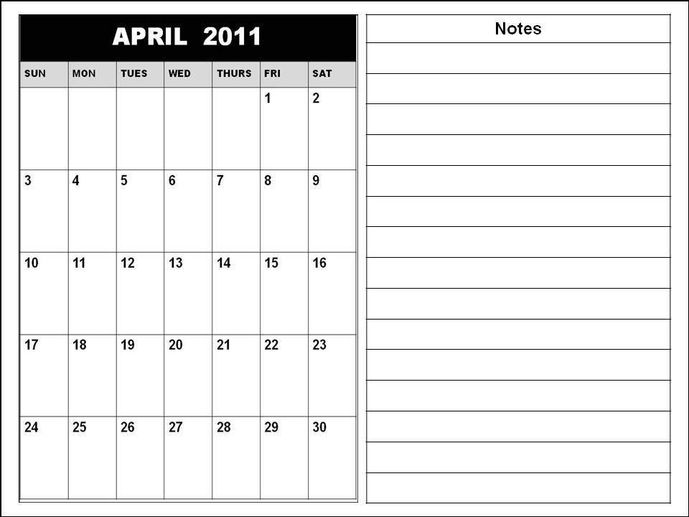
Start
Name
Day
- Click a specific day on calendar
- Show up “Appointment Window”
- Write a contents of Note fields
and Click Confirm
Start
Name
End
Day
Location
People
Description
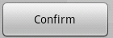

4 / 4 / 2011
Color marked day got a note now

Same color markers shows same appointments

a)
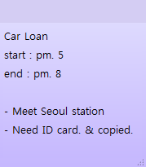
- Click a specific day on calendar
MARCH
Start
Title
End
Date
Location
Participation
Description
Volunteer Work
2 PM
7 PM
Korea univ.
Colleague
Sometimes location will be changed.
Every week
Every month
- Input multiple dates
- Fill contents of the Note field
- Click confirm
2,9,16,23 / 4 / 2011

b)
1. Click a specific day on calendar
2. Check the box either every week or
every month
3. click confirm

